myFormBuilder - Project Initiation Document

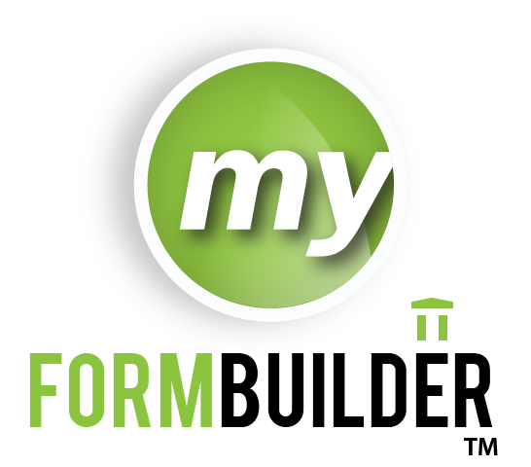

Document Sign-Off

|  |  |  |
| --- | --- | --- |
| Simon Cowan  Innovation Software Manager,  Test Development Solutions |  | Date |

|  |  |  |
| --- | --- | --- |
| Micheal Tiernan  Software Developer & QC Lead,  Test Development Solutions |  | Date |

|  |  |  |
| --- | --- | --- |
| Patrick MacCnaimhin  Software Developer,  Test Development Solutions |  | Date |

|  |  |  |
| --- | --- | --- |
| Barry McGivern  DBA,  Test Development Solutions |  | Date |

|  |  |  |
| --- | --- | --- |
| Cahail Kiernans  Graphic Design Manager,  Test Development Solutions |  | Date |
| Sharon Mooney  Business Analyst,  Test Development Solutions |  | Date |

**Contents**

1. Scope 4

2. myFormBuilder Value Statement 5

3. Clarifications 6

4. The myFormBuilder Application 7

4.1 Suggested Architecture 7

4.1.1 Web Services 7

4.1.2 Database 8

4.1.3 System 8

4.1.4 Security and Content 8

4.1.5 Previewing Content in myFormBuilder 8

4.1.6 Creating a Form 9

4.2 Wire-Frames 9

5. Risks 10

6. Timelines 11

7. Assumptions 12

**Version History**

|  |  |  |  |
| --- | --- | --- | --- |
| Ver. # | Revision Date Day, Month, Year | Author of Change | Description of Changes to Document |
| 1.0 | 11/10/2013 | Micheal Tiernan | Initial draft |
|  |  |  |  |
|  |  |  |  |
|  |  |  |  |

# Scope

The scope of this document is to outline the questions that need to be addressed in order to start the development of the myFormBuilder application. It will also look at a suggested architecture based on certain assumptions and a brief description of some of the main points of concern to date.

# myFormBuilder Value Statement

“MyFormBuilder… “

# Clarifications

In order to get a better understanding of the aim of this project and how the final solution should function, we need to get clarification on a number of important questions. These questions are listed below:

1. **What is the expected overall output(s) of the MyFormBuilder application?**
   1. A new form(s) created **WITHIN** the Intelitest system

*In this case, the best option would be to build the myFormBuilder application as a new project within the Intelitest solution.*

* 1. The structure of a form created and stored in a new lightweight application **OUTSIDE** of the Intelitest solution and using Intelitest as an item bank only.

*This option would require an export of the form from myFormBuilder in a new format (e.g. XML, HTML, Excel, PDF etc.). This new format would also need to be agreed upon.*

* 1. Other. To be described by the stakeholders if neither of the above options apply.

1. **What is the full list of criteria to be used for searching for items to be added to a form?**

This should be described and agreed upon before development begins. Examples include level of difficulty, item type, item state, custom fields etc.

1. **Who is / who are the expected user(s) of myFormBuilder?**

In order to be able to better design the system to the needs of the user, the target users should be identified and their input taken into the development of the final solution.

1. **Is there any other expected functionality that has not been mentioned in this document?**

If there is any functionality that is expected of the myFormBuilder application that has not been mentioned throughout this document, this should be highlighted.

# The myFormBuilder Application

## Suggested Architecture

The following outlines the suggested architecture for how a user will interact with the myFormBuilder application and also how myFormBuilder will interact with the Intelitest system. Please note that the in the following diagram, the ‘myFormBuilder Form DB’ may be replaced instead with an additional table in the Intelitest DB depending on what the overall output of the system is determined to be.

|  |
| --- |
|  |

### Web Services

Windows Communication Foundation (WCF) web services will be utilized in order to retrieve data from the Intelitest system. WCF web services support .NET4.5 and also implement Service-Orientated Architecture (SOA) which uses a Web Service Description Language (WSDL) that other WCF clients can consume. Intelitest already supports some of these web services, but additional web services may need to be added in order to supply the necessary information to the myFormBuilder application. All data will use HttpBinding and Message Transmission Optimization Mechanism (MTOM) which ensures all data is optimized and encrypted. All this encrypted data will be sent over a Secure Sockets Layer (SSL) transmission.

### Database

Depending on the direction that the myFormBuilder application will take, there are two possible options for storing the form data. These are:

1. A new database will be created and hosted on our Production servers in Baltimore and maintained through Microsoft SQL Server Management Studio. This database will be used only to store form specific information and structures and will not store any content retrieved from Intelitest. In this scenario, Intelitest will be used mainly as an item bank by myFormBuilder.
2. A new table(s) will be created in the current Intelitest database the will store all the form structure and other information. This scenario will be used if the myFormBuilder application is determined to be an additional product within the Intelitest solution (i.e. if the output is required to be an Intelitest form) as opposed to a separate standalone project.

### System

The myFormBuilder application will be developed as a Web Based ASP.Net application hosted on our servers in Baltimore and accessible from any location. It will be developed within the Microsoft Visual Studio environment utilizing the capabilities of the Microsoft C# language.

### Security and Content

The myFormBuilder application will not store Intelitest content within its database. Instead, it will use a secure method to retrieve content from the application, display the content and allow forms to be built based on the item content supplied. These forms will then be stored in the myFormBuilder database however, only information specific to the structure of the form will be stored.

Another form of security that will be employed is that the myFormBuilder application will require user credentials from the Intelitest system in order to log in. This will enable us to restrict a user’s access to content by using the security already developed within the Intelitest solution.

### Previewing Content in myFormBuilder

There will be in built functionality in the myFormBuilder application to preview the items if necessary. This functionality though will not be a preview of how the content will be displayed in the UTD driver and will be used only to verify the content.

### Creating a Form

In order to create a form in myFormBuilder, the user will be requested to enter details about the form and the types of items to be used. Based on this information, the system should then be able to generate a form(s) automatically that meet the criteria set out by the user. Alternatively, a user would be able to get a full list of all items that fit a given criteria and then manually specify which items to add to a form(s).

At any point after a user has started to create a new form, they will have the option to save the form details to be completed or to be re-exported at a later time. This will then store an entry for the form in the database with all data entered up to that point.

## Wire-Frames

Wire-frames for the application are not currently available. They will be created and made available at a later date when all design considerations and questions have received answers and development is ready to commence.

# Timelines

1. Design, Analysis, Workflows and DB design Defined

**Date** -

1. Workflow, Technical Architecture, UI Design, BRD and Project Plan – 8 Week Sprint

**Date –**

1. First Release

**Date –**

1. Beta Release – Prototype, Full End to End Functionality and stable Environments

**Date-**

# Risks

The risks we have identified are as follows

* As the content is not being stored in the myFormBuilder database, the application will require access to the Intelitest system to function correctly
* All questions outlined in the Clarifications section will need to be addressed prior to development
* With the suggested design, a user will not be able to use the myFormBuilder application unless they have valid credentials for the Intelitest system

# Assumptions

* It will be assumed that all users of the myFormBuilder application will have an account in the Intelitest system
* Users will have the ability to re-export a form if they want to swap out items